1 run......

Downloading: 100%

464/464 [00:00<00:00, 11.3kB/s]

Downloading: 100%

270M/270M [00:10<00:00, 28.9MB/s]

training 1 epoch...

33.673774003982544 seconds used......

1 training finished! average train loss: 0.46439124074281823

evaluating...

Confusion matrix, without normalization

[[ 0 0 41 0]

[ 0 0 77 0]

[ 0 0 714 0]

[ 0 0 18 0]]

Normalized confusion matrix

[[0. 0. 1. 0.]

[0. 0. 1. 0.]

[0. 0. 1. 0.]

[0. 0. 1. 0.]]

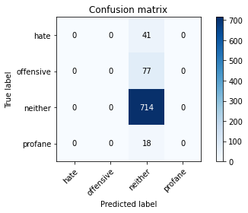

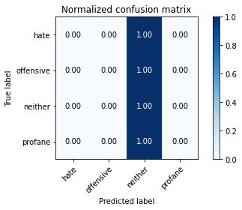

/opt/conda/lib/python3.7/site-packages/sklearn/metrics/_classification.py:1245: UndefinedMetricWarning: Precision and F-score are ill-defined and being set to 0.0 in labels with no predicted samples. Use `zero_division` parameter to control this behavior.

_warn_prf(average, modifier, msg_start, len(result))

/opt/conda/lib/python3.7/site-packages/sklearn/metrics/_classification.py:1245: UndefinedMetricWarning: Precision and F-score are ill-defined and being set to 0.0 in labels with no predicted samples. Use `zero_division` parameter to control this behavior.

_warn_prf(average, modifier, msg_start, len(result))

/opt/conda/lib/python3.7/site-packages/sklearn/metrics/_classification.py:1245: UndefinedMetricWarning: Precision and F-score are ill-defined and being set to 0.0 in labels with no predicted samples. Use `zero_division` parameter to control this behavior.

_warn_prf(average, modifier, msg_start, len(result))

precision recall f1-score support

hate 0.00 0.00 0.00 41

offensive 0.00 0.00 0.00 77

neither 0.84 1.00 0.91 714

profane 0.00 0.00 0.00 18

accuracy 0.84 850

macro avg 0.21 0.25 0.23 850

weighted avg 0.71 0.84 0.77 850

average eval_loss: 0.5679327070193235, accuracy: 0.84

training 2 epoch...

32.94081783294678 seconds used......

2 training finished! average train loss: 0.3728520834321127

evaluating...

Confusion matrix, without normalization

[[ 0 0 41 0]

[ 0 0 77 0]

[ 0 0 714 0]

[ 0 0 18 0]]

Normalized confusion matrix

[[0. 0. 1. 0.]

[0. 0. 1. 0.]

[0. 0. 1. 0.]

[0. 0. 1. 0.]]





/opt/conda/lib/python3.7/site-packages/sklearn/metrics/_classification.py:1245: UndefinedMetricWarning: Precision and F-score are ill-defined and being set to 0.0 in labels with no predicted samples. Use `zero_division` parameter to control this behavior.

_warn_prf(average, modifier, msg_start, len(result))

/opt/conda/lib/python3.7/site-packages/sklearn/metrics/_classification.py:1245: UndefinedMetricWarning: Precision and F-score are ill-defined and being set to 0.0 in labels with no predicted samples. Use `zero_division` parameter to control this behavior.

_warn_prf(average, modifier, msg_start, len(result))

/opt/conda/lib/python3.7/site-packages/sklearn/metrics/_classification.py:1245: UndefinedMetricWarning: Precision and F-score are ill-defined and being set to 0.0 in labels with no predicted samples. Use `zero_division` parameter to control this behavior.

_warn_prf(average, modifier, msg_start, len(result))

precision recall f1-score support

hate 0.00 0.00 0.00 41

offensive 0.00 0.00 0.00 77

neither 0.84 1.00 0.91 714

profane 0.00 0.00 0.00 18

accuracy 0.84 850

macro avg 0.21 0.25 0.23 850

weighted avg 0.71 0.84 0.77 850

average eval_loss: 0.7019729902967811, accuracy: 0.84

training 3 epoch...

32.7925980091095 seconds used......

3 training finished! average train loss: 0.2594509099498001

evaluating...

Confusion matrix, without normalization

[[ 1 1 39 0]

[ 1 0 76 0]

[ 3 4 706 1]

[ 0 1 17 0]]

Normalized confusion matrix

[[0.02439024 0.02439024 0.95121951 0. ]

[0.01298701 0. 0.98701299 0. ]

[0.00420168 0.00560224 0.98879552 0.00140056]

[0. 0.05555556 0.94444444 0. ]]

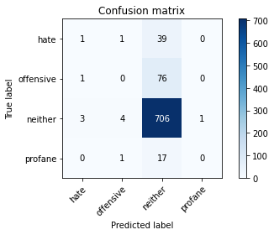

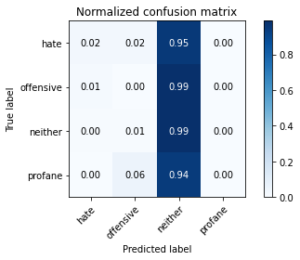

precision recall f1-score support

hate 0.20 0.02 0.04 41

offensive 0.00 0.00 0.00 77

neither 0.84 0.99 0.91 714

profane 0.00 0.00 0.00 18

accuracy 0.83 850

macro avg 0.26 0.25 0.24 850

weighted avg 0.72 0.83 0.77 850

average eval_loss: 0.6523382576442388, accuracy: 0.831764705882353

training 4 epoch...

32.86971616744995 seconds used......

4 training finished! average train loss: 0.12613806323299467

evaluating...

Confusion matrix, without normalization

[[ 0 3 38 0]

[ 2 2 73 0]

[ 2 3 706 3]

[ 0 1 16 1]]

Normalized confusion matrix

[[0. 0.07317073 0.92682927 0. ]

[0.02597403 0.02597403 0.94805195 0. ]

[0.00280112 0.00420168 0.98879552 0.00420168]

[0. 0.05555556 0.88888889 0.05555556]]

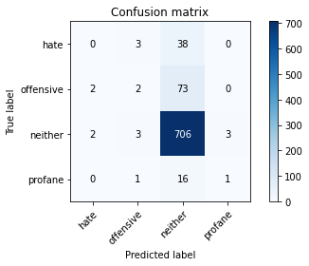

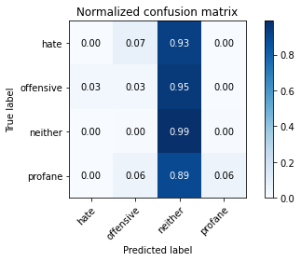

precision recall f1-score support

hate 0.00 0.00 0.00 41

offensive 0.22 0.03 0.05 77

neither 0.85 0.99 0.91 714

profane 0.25 0.06 0.09 18

accuracy 0.83 850

macro avg 0.33 0.27 0.26 850

weighted avg 0.74 0.83 0.77 850

average eval_loss: 0.8751383742187605, accuracy: 0.8341176470588235

training 5 epoch...

32.8480281829834 seconds used......

5 training finished! average train loss: 0.05696164788641718

evaluating...

Confusion matrix, without normalization

[[ 2 4 35 0]

[ 2 8 67 0]

[ 7 15 689 3]

[ 0 2 15 1]]

Normalized confusion matrix

[[0.04878049 0.09756098 0.85365854 0. ]

[0.02597403 0.1038961 0.87012987 0. ]

[0.00980392 0.0210084 0.96498599 0.00420168]

[0. 0.11111111 0.83333333 0.05555556]]

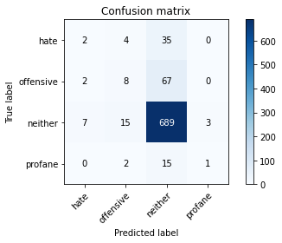

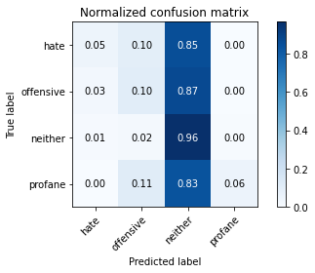

precision recall f1-score support

hate 0.18 0.05 0.08 41

offensive 0.28 0.10 0.15 77

neither 0.85 0.96 0.91 714

profane 0.25 0.06 0.09 18

accuracy 0.82 850

macro avg 0.39 0.29 0.31 850

weighted avg 0.76 0.82 0.78 850

average eval_loss: 0.9546334980310179, accuracy: 0.8235294117647058

training 6 epoch...

32.94485545158386 seconds used......

6 training finished! average train loss: 0.02442704740892218

evaluating...

Confusion matrix, without normalization

[[ 1 2 38 0]

[ 4 6 67 0]

[ 10 9 694 1]

[ 0 1 16 1]]

Normalized confusion matrix

[[0.02439024 0.04878049 0.92682927 0. ]

[0.05194805 0.07792208 0.87012987 0. ]

[0.0140056 0.01260504 0.9719888 0.00140056]

[0. 0.05555556 0.88888889 0.05555556]]

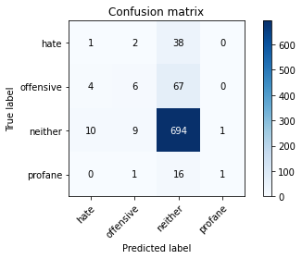

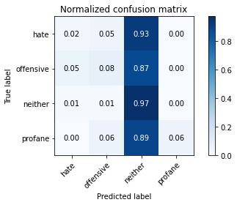

precision recall f1-score support

hate 0.07 0.02 0.04 41

offensive 0.33 0.08 0.13 77

neither 0.85 0.97 0.91 714

profane 0.50 0.06 0.10 18

accuracy 0.83 850

macro avg 0.44 0.28 0.29 850

weighted avg 0.76 0.83 0.78 850

average eval_loss: 1.133174217660738, accuracy: 0.8258823529411765

training 7 epoch...

32.89141631126404 seconds used......

7 training finished! average train loss: 0.00716403426196553

evaluating...

Confusion matrix, without normalization

[[ 0 4 37 0]

[ 4 6 67 0]

[ 7 12 691 4]

[ 0 2 15 1]]

Normalized confusion matrix

[[0. 0.09756098 0.90243902 0. ]

[0.05194805 0.07792208 0.87012987 0. ]

[0.00980392 0.01680672 0.96778711 0.00560224]

[0. 0.11111111 0.83333333 0.05555556]]

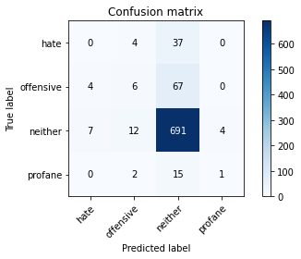

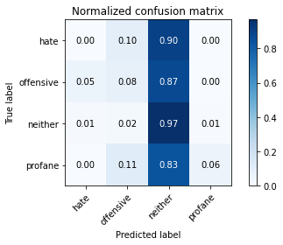

precision recall f1-score support

hate 0.00 0.00 0.00 41

offensive 0.25 0.08 0.12 77

neither 0.85 0.97 0.91 714

profane 0.20 0.06 0.09 18

accuracy 0.82 850

macro avg 0.33 0.28 0.28 850

weighted avg 0.74 0.82 0.77 850

average eval_loss: 1.2442213330921434, accuracy: 0.8211764705882353

training 8 epoch...

32.89227890968323 seconds used......

8 training finished! average train loss: 0.0026115055647172787

evaluating...

Confusion matrix, without normalization

[[ 1 2 38 0]

[ 3 3 71 0]

[ 8 9 694 3]

[ 0 2 15 1]]

Normalized confusion matrix

[[0.02439024 0.04878049 0.92682927 0. ]

[0.03896104 0.03896104 0.92207792 0. ]

[0.01120448 0.01260504 0.9719888 0.00420168]

[0. 0.11111111 0.83333333 0.05555556]]

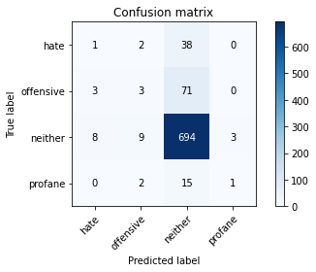

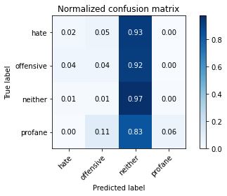

precision recall f1-score support

hate 0.08 0.02 0.04 41

offensive 0.19 0.04 0.06 77

neither 0.85 0.97 0.91 714

profane 0.25 0.06 0.09 18

accuracy 0.82 850

macro avg 0.34 0.27 0.27 850

weighted avg 0.74 0.82 0.77 850

average eval_loss: 1.3452190408127134, accuracy: 0.8223529411764706

training 9 epoch...

32.905433893203735 seconds used......

9 training finished! average train loss: 0.0014193451661508071

evaluating...

Confusion matrix, without normalization

[[ 1 2 38 0]

[ 2 4 71 0]

[ 6 8 696 4]

[ 0 1 16 1]]

Normalized confusion matrix

[[0.02439024 0.04878049 0.92682927 0. ]

[0.02597403 0.05194805 0.92207792 0. ]

[0.00840336 0.01120448 0.97478992 0.00560224]

[0. 0.05555556 0.88888889 0.05555556]]

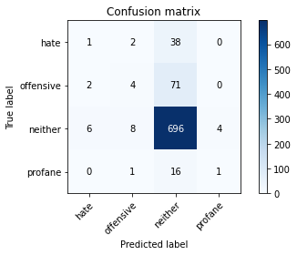

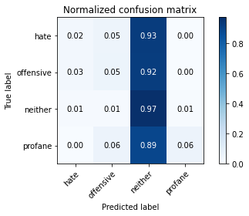

precision recall f1-score support

hate 0.11 0.02 0.04 41

offensive 0.27 0.05 0.09 77

neither 0.85 0.97 0.91 714

profane 0.20 0.06 0.09 18

accuracy 0.83 850

macro avg 0.36 0.28 0.28 850

weighted avg 0.75 0.83 0.77 850

average eval_loss: 1.3950684404895413, accuracy: 0.8258823529411765

training 10 epoch...

32.803767919540405 seconds used......

10 training finished! average train loss: 0.0008923256390664668

evaluating...

Confusion matrix, without normalization

[[ 0 1 40 0]

[ 2 3 72 0]

[ 3 8 702 1]

[ 0 1 16 1]]

Normalized confusion matrix

[[0. 0.02439024 0.97560976 0. ]

[0.02597403 0.03896104 0.93506494 0. ]

[0.00420168 0.01120448 0.98319328 0.00140056]

[0. 0.05555556 0.88888889 0.05555556]]

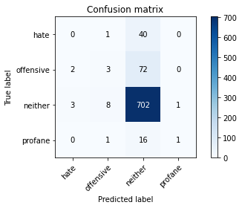

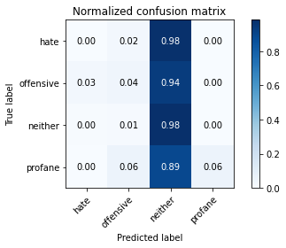

precision recall f1-score support

hate 0.00 0.00 0.00 41

offensive 0.23 0.04 0.07 77

neither 0.85 0.98 0.91 714

profane 0.50 0.06 0.10 18

accuracy 0.83 850

macro avg 0.39 0.27 0.27 850

weighted avg 0.74 0.83 0.77 850

average eval_loss: 1.4681005596753811, accuracy: 0.8305882352941176

2 run......

training 1 epoch...

32.87400269508362 seconds used......

1 training finished! average train loss: 0.4685832128825924

evaluating...

Confusion matrix, without normalization

[[ 0 0 41 0]

[ 0 0 77 0]

[ 0 0 714 0]

[ 0 0 18 0]]

Normalized confusion matrix

[[0. 0. 1. 0.]

[0. 0. 1. 0.]

[0. 0. 1. 0.]

[0. 0. 1. 0.]]





/opt/conda/lib/python3.7/site-packages/sklearn/metrics/_classification.py:1245: UndefinedMetricWarning: Precision and F-score are ill-defined and being set to 0.0 in labels with no predicted samples. Use `zero_division` parameter to control this behavior.

_warn_prf(average, modifier, msg_start, len(result))

/opt/conda/lib/python3.7/site-packages/sklearn/metrics/_classification.py:1245: UndefinedMetricWarning: Precision and F-score are ill-defined and being set to 0.0 in labels with no predicted samples. Use `zero_division` parameter to control this behavior.

_warn_prf(average, modifier, msg_start, len(result))

/opt/conda/lib/python3.7/site-packages/sklearn/metrics/_classification.py:1245: UndefinedMetricWarning: Precision and F-score are ill-defined and being set to 0.0 in labels with no predicted samples. Use `zero_division` parameter to control this behavior.

_warn_prf(average, modifier, msg_start, len(result))

precision recall f1-score support

hate 0.00 0.00 0.00 41

offensive 0.00 0.00 0.00 77

neither 0.84 1.00 0.91 714

profane 0.00 0.00 0.00 18

accuracy 0.84 850

macro avg 0.21 0.25 0.23 850

weighted avg 0.71 0.84 0.77 850

average eval_loss: 0.5607179062830847, accuracy: 0.84

training 2 epoch...

32.95246434211731 seconds used......

2 training finished! average train loss: 0.37294468104215195

evaluating...

Confusion matrix, without normalization

[[ 0 1 40 0]

[ 0 0 77 0]

[ 0 2 711 1]

[ 0 0 18 0]]

Normalized confusion matrix

[[0. 0.02439024 0.97560976 0. ]

[0. 0. 1. 0. ]

[0. 0.00280112 0.99579832 0.00140056]

[0. 0. 1. 0. ]]

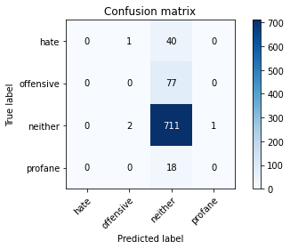

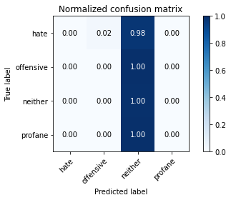

/opt/conda/lib/python3.7/site-packages/sklearn/metrics/_classification.py:1245: UndefinedMetricWarning: Precision and F-score are ill-defined and being set to 0.0 in labels with no predicted samples. Use `zero_division` parameter to control this behavior.

_warn_prf(average, modifier, msg_start, len(result))

/opt/conda/lib/python3.7/site-packages/sklearn/metrics/_classification.py:1245: UndefinedMetricWarning: Precision and F-score are ill-defined and being set to 0.0 in labels with no predicted samples. Use `zero_division` parameter to control this behavior.

_warn_prf(average, modifier, msg_start, len(result))

/opt/conda/lib/python3.7/site-packages/sklearn/metrics/_classification.py:1245: UndefinedMetricWarning: Precision and F-score are ill-defined and being set to 0.0 in labels with no predicted samples. Use `zero_division` parameter to control this behavior.

_warn_prf(average, modifier, msg_start, len(result))

precision recall f1-score support

hate 0.00 0.00 0.00 41

offensive 0.00 0.00 0.00 77

neither 0.84 1.00 0.91 714

profane 0.00 0.00 0.00 18

accuracy 0.84 850

macro avg 0.21 0.25 0.23 850

weighted avg 0.71 0.84 0.77 850

average eval_loss: 0.5163154899207658, accuracy: 0.8364705882352941

training 3 epoch...

32.90202760696411 seconds used......

3 training finished! average train loss: 0.2625484262149371

evaluating...

Confusion matrix, without normalization

[[ 0 1 40 0]

[ 1 1 75 0]

[ 3 9 700 2]

[ 0 0 17 1]]

Normalized confusion matrix

[[0. 0.02439024 0.97560976 0. ]

[0.01298701 0.01298701 0.97402597 0. ]

[0.00420168 0.01260504 0.98039216 0.00280112]

[0. 0. 0.94444444 0.05555556]]

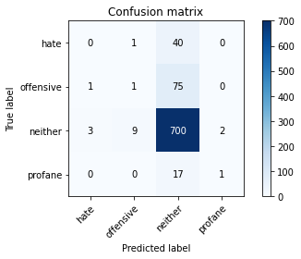

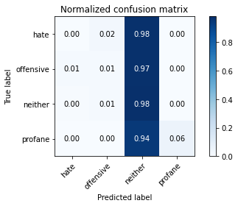

precision recall f1-score support

hate 0.00 0.00 0.00 41

offensive 0.09 0.01 0.02 77

neither 0.84 0.98 0.91 714

profane 0.33 0.06 0.10 18

accuracy 0.83 850

macro avg 0.32 0.26 0.26 850

weighted avg 0.72 0.83 0.76 850

average eval_loss: 0.6346828693870542, accuracy: 0.8258823529411765

training 4 epoch...

32.98791027069092 seconds used......

4 training finished! average train loss: 0.12599349389077014

evaluating...

Confusion matrix, without normalization

[[ 0 1 40 0]

[ 1 2 74 0]

[ 1 8 703 2]

[ 0 1 17 0]]

Normalized confusion matrix

[[0. 0.02439024 0.97560976 0. ]

[0.01298701 0.02597403 0.96103896 0. ]

[0.00140056 0.01120448 0.98459384 0.00280112]

[0. 0.05555556 0.94444444 0. ]]

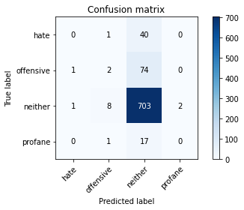

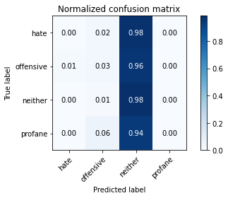

precision recall f1-score support

hate 0.00 0.00 0.00 41

offensive 0.17 0.03 0.04 77

neither 0.84 0.98 0.91 714

profane 0.00 0.00 0.00 18

accuracy 0.83 850

macro avg 0.25 0.25 0.24 850

weighted avg 0.72 0.83 0.77 850

average eval_loss: 0.8846737676581671, accuracy: 0.8294117647058824

training 5 epoch...

32.8646035194397 seconds used......

5 training finished! average train loss: 0.04768369111710311

evaluating...

Confusion matrix, without normalization

[[ 0 2 39 0]

[ 0 19 58 0]

[ 5 16 690 3]

[ 0 5 13 0]]

Normalized confusion matrix

[[0. 0.04878049 0.95121951 0. ]

[0. 0.24675325 0.75324675 0. ]

[0.0070028 0.02240896 0.96638655 0.00420168]

[0. 0.27777778 0.72222222 0. ]]

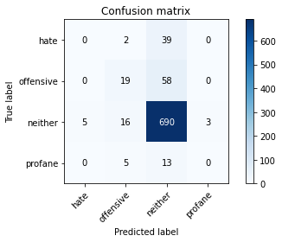

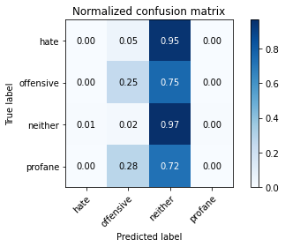

precision recall f1-score support

hate 0.00 0.00 0.00 41

offensive 0.45 0.25 0.32 77

neither 0.86 0.97 0.91 714

profane 0.00 0.00 0.00 18

accuracy 0.83 850

macro avg 0.33 0.30 0.31 850

weighted avg 0.77 0.83 0.79 850

average eval_loss: 0.7889687226419229, accuracy: 0.8341176470588235

training 6 epoch...

32.765403032302856 seconds used......

6 training finished! average train loss: 0.020642951597442546

evaluating...

Confusion matrix, without normalization

[[ 0 2 39 0]

[ 0 4 73 0]

[ 3 11 699 1]

[ 0 1 17 0]]

Normalized confusion matrix

[[0. 0.04878049 0.95121951 0. ]

[0. 0.05194805 0.94805195 0. ]

[0.00420168 0.01540616 0.9789916 0.00140056]

[0. 0.05555556 0.94444444 0. ]]

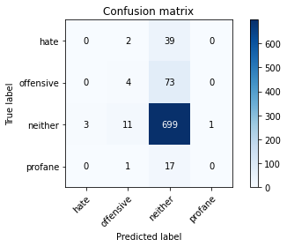

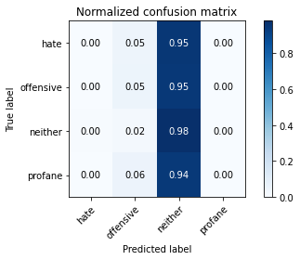

precision recall f1-score support

hate 0.00 0.00 0.00 41

offensive 0.22 0.05 0.08 77

neither 0.84 0.98 0.91 714

profane 0.00 0.00 0.00 18

accuracy 0.83 850

macro avg 0.27 0.26 0.25 850

weighted avg 0.73 0.83 0.77 850

average eval_loss: 1.1350377684006965, accuracy: 0.8270588235294117

training 7 epoch...

32.85915493965149 seconds used......

7 training finished! average train loss: 0.011765545043461658

evaluating...

Confusion matrix, without normalization

[[ 0 2 39 0]

[ 0 7 70 0]

[ 2 21 688 3]

[ 0 4 14 0]]

Normalized confusion matrix

[[0. 0.04878049 0.95121951 0. ]

[0. 0.09090909 0.90909091 0. ]

[0.00280112 0.02941176 0.96358543 0.00420168]

[0. 0.22222222 0.77777778 0. ]]

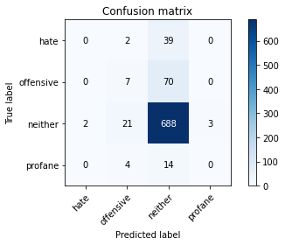

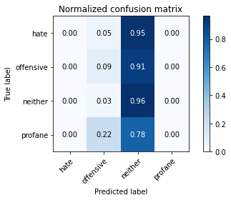

precision recall f1-score support

hate 0.00 0.00 0.00 41

offensive 0.21 0.09 0.13 77

neither 0.85 0.96 0.90 714

profane 0.00 0.00 0.00 18

accuracy 0.82 850

macro avg 0.26 0.26 0.26 850

weighted avg 0.73 0.82 0.77 850

average eval_loss: 1.183427419805179, accuracy: 0.8176470588235294

training 8 epoch...

32.70962190628052 seconds used......

8 training finished! average train loss: 0.002978718051649094

evaluating...

Confusion matrix, without normalization

[[ 0 4 37 0]

[ 0 8 69 0]

[ 5 18 685 6]

[ 0 4 14 0]]

Normalized confusion matrix

[[0. 0.09756098 0.90243902 0. ]

[0. 0.1038961 0.8961039 0. ]

[0.0070028 0.02521008 0.95938375 0.00840336]

[0. 0.22222222 0.77777778 0. ]]

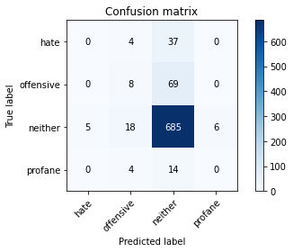

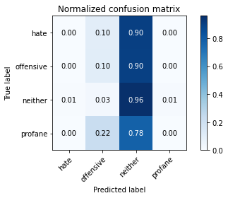

precision recall f1-score support

hate 0.00 0.00 0.00 41

offensive 0.24 0.10 0.14 77

neither 0.85 0.96 0.90 714

profane 0.00 0.00 0.00 18

accuracy 0.82 850

macro avg 0.27 0.27 0.26 850

weighted avg 0.74 0.82 0.77 850

average eval_loss: 1.1849832173232477, accuracy: 0.8152941176470588

training 9 epoch...

32.8841392993927 seconds used......

9 training finished! average train loss: 0.0024435971071974116

evaluating...

Confusion matrix, without normalization

[[ 0 4 37 0]

[ 0 9 68 0]

[ 7 18 686 3]

[ 0 6 12 0]]

Normalized confusion matrix

[[0. 0.09756098 0.90243902 0. ]

[0. 0.11688312 0.88311688 0. ]

[0.00980392 0.02521008 0.96078431 0.00420168]

[0. 0.33333333 0.66666667 0. ]]

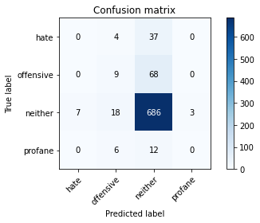

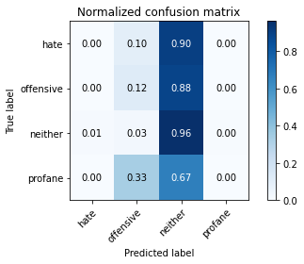

precision recall f1-score support

hate 0.00 0.00 0.00 41

offensive 0.24 0.12 0.16 77

neither 0.85 0.96 0.90 714

profane 0.00 0.00 0.00 18

accuracy 0.82 850

macro avg 0.27 0.27 0.27 850

weighted avg 0.74 0.82 0.77 850

average eval_loss: 1.2563802327921474, accuracy: 0.8176470588235294

training 10 epoch...

32.81174993515015 seconds used......

10 training finished! average train loss: 0.00806073088757968

evaluating...

Confusion matrix, without normalization

[[ 0 1 40 0]

[ 0 5 71 1]

[ 0 11 702 1]

[ 0 3 15 0]]

Normalized confusion matrix

[[0. 0.02439024 0.97560976 0. ]

[0. 0.06493506 0.92207792 0.01298701]

[0. 0.01540616 0.98319328 0.00140056]

[0. 0.16666667 0.83333333 0. ]]

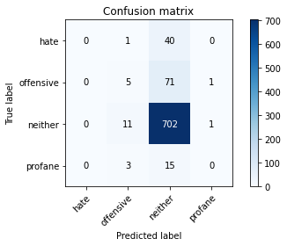

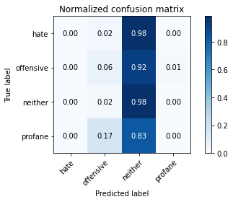

/opt/conda/lib/python3.7/site-packages/sklearn/metrics/_classification.py:1245: UndefinedMetricWarning: Precision and F-score are ill-defined and being set to 0.0 in labels with no predicted samples. Use `zero_division` parameter to control this behavior.

_warn_prf(average, modifier, msg_start, len(result))

/opt/conda/lib/python3.7/site-packages/sklearn/metrics/_classification.py:1245: UndefinedMetricWarning: Precision and F-score are ill-defined and being set to 0.0 in labels with no predicted samples. Use `zero_division` parameter to control this behavior.

_warn_prf(average, modifier, msg_start, len(result))

/opt/conda/lib/python3.7/site-packages/sklearn/metrics/_classification.py:1245: UndefinedMetricWarning: Precision and F-score are ill-defined and being set to 0.0 in labels with no predicted samples. Use `zero_division` parameter to control this behavior.

_warn_prf(average, modifier, msg_start, len(result))

precision recall f1-score support

hate 0.00 0.00 0.00 41

offensive 0.25 0.06 0.10 77

neither 0.85 0.98 0.91 714

profane 0.00 0.00 0.00 18

accuracy 0.83 850

macro avg 0.27 0.26 0.25 850

weighted avg 0.73 0.83 0.77 850

average eval_loss: 1.2608141310480532, accuracy: 0.831764705882353

3 run......

training 1 epoch...

32.8964741230011 seconds used......

1 training finished! average train loss: 0.47604699978965737

evaluating...

Confusion matrix, without normalization

[[ 0 0 41 0]

[ 0 0 77 0]

[ 0 0 714 0]

[ 0 0 18 0]]

Normalized confusion matrix

[[0. 0. 1. 0.]

[0. 0. 1. 0.]

[0. 0. 1. 0.]

[0. 0. 1. 0.]]





/opt/conda/lib/python3.7/site-packages/sklearn/metrics/_classification.py:1245: UndefinedMetricWarning: Precision and F-score are ill-defined and being set to 0.0 in labels with no predicted samples. Use `zero_division` parameter to control this behavior.

_warn_prf(average, modifier, msg_start, len(result))

/opt/conda/lib/python3.7/site-packages/sklearn/metrics/_classification.py:1245: UndefinedMetricWarning: Precision and F-score are ill-defined and being set to 0.0 in labels with no predicted samples. Use `zero_division` parameter to control this behavior.

_warn_prf(average, modifier, msg_start, len(result))

/opt/conda/lib/python3.7/site-packages/sklearn/metrics/_classification.py:1245: UndefinedMetricWarning: Precision and F-score are ill-defined and being set to 0.0 in labels with no predicted samples. Use `zero_division` parameter to control this behavior.

_warn_prf(average, modifier, msg_start, len(result))

precision recall f1-score support

hate 0.00 0.00 0.00 41

offensive 0.00 0.00 0.00 77

neither 0.84 1.00 0.91 714

profane 0.00 0.00 0.00 18

accuracy 0.84 850

macro avg 0.21 0.25 0.23 850

weighted avg 0.71 0.84 0.77 850

average eval_loss: 0.587551126906345, accuracy: 0.84

training 2 epoch...

32.9085955619812 seconds used......

2 training finished! average train loss: 0.37924048487896694

evaluating...

Confusion matrix, without normalization

[[ 0 0 41 0]

[ 0 0 77 0]

[ 0 0 714 0]

[ 0 0 18 0]]

Normalized confusion matrix

[[0. 0. 1. 0.]

[0. 0. 1. 0.]

[0. 0. 1. 0.]

[0. 0. 1. 0.]]





/opt/conda/lib/python3.7/site-packages/sklearn/metrics/_classification.py:1245: UndefinedMetricWarning: Precision and F-score are ill-defined and being set to 0.0 in labels with no predicted samples. Use `zero_division` parameter to control this behavior.

_warn_prf(average, modifier, msg_start, len(result))

/opt/conda/lib/python3.7/site-packages/sklearn/metrics/_classification.py:1245: UndefinedMetricWarning: Precision and F-score are ill-defined and being set to 0.0 in labels with no predicted samples. Use `zero_division` parameter to control this behavior.

_warn_prf(average, modifier, msg_start, len(result))

/opt/conda/lib/python3.7/site-packages/sklearn/metrics/_classification.py:1245: UndefinedMetricWarning: Precision and F-score are ill-defined and being set to 0.0 in labels with no predicted samples. Use `zero_division` parameter to control this behavior.

_warn_prf(average, modifier, msg_start, len(result))

precision recall f1-score support

hate 0.00 0.00 0.00 41

offensive 0.00 0.00 0.00 77

neither 0.84 1.00 0.91 714

profane 0.00 0.00 0.00 18

accuracy 0.84 850

macro avg 0.21 0.25 0.23 850

weighted avg 0.71 0.84 0.77 850

average eval_loss: 0.567086556774759, accuracy: 0.84

training 3 epoch...

33.056567907333374 seconds used......

3 training finished! average train loss: 0.263230876821576

evaluating...

Confusion matrix, without normalization

[[ 0 4 37 0]

[ 1 5 71 0]

[ 3 16 695 0]

[ 0 2 16 0]]

Normalized confusion matrix

[[0. 0.09756098 0.90243902 0. ]

[0.01298701 0.06493506 0.92207792 0. ]

[0.00420168 0.02240896 0.97338936 0. ]

[0. 0.11111111 0.88888889 0. ]]

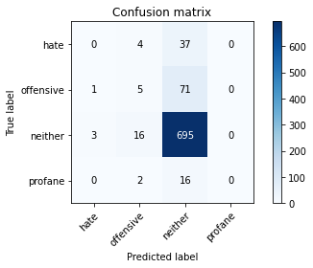

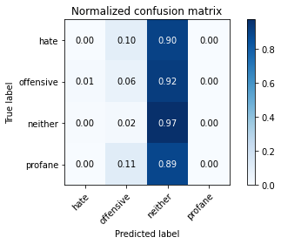

/opt/conda/lib/python3.7/site-packages/sklearn/metrics/_classification.py:1245: UndefinedMetricWarning: Precision and F-score are ill-defined and being set to 0.0 in labels with no predicted samples. Use `zero_division` parameter to control this behavior.

_warn_prf(average, modifier, msg_start, len(result))

/opt/conda/lib/python3.7/site-packages/sklearn/metrics/_classification.py:1245: UndefinedMetricWarning: Precision and F-score are ill-defined and being set to 0.0 in labels with no predicted samples. Use `zero_division` parameter to control this behavior.

_warn_prf(average, modifier, msg_start, len(result))

/opt/conda/lib/python3.7/site-packages/sklearn/metrics/_classification.py:1245: UndefinedMetricWarning: Precision and F-score are ill-defined and being set to 0.0 in labels with no predicted samples. Use `zero_division` parameter to control this behavior.

_warn_prf(average, modifier, msg_start, len(result))

precision recall f1-score support

hate 0.00 0.00 0.00 41

offensive 0.19 0.06 0.10 77

neither 0.85 0.97 0.91 714

profane 0.00 0.00 0.00 18

accuracy 0.82 850

macro avg 0.26 0.26 0.25 850

weighted avg 0.73 0.82 0.77 850

average eval_loss: 0.6045763768732201, accuracy: 0.8235294117647058

training 4 epoch...

33.00987482070923 seconds used......

4 training finished! average train loss: 0.13659175393459294

evaluating...

Confusion matrix, without normalization

[[ 2 14 25 0]

[ 1 9 67 0]

[ 6 41 665 2]

[ 0 5 13 0]]

Normalized confusion matrix

[[0.04878049 0.34146341 0.6097561 0. ]

[0.01298701 0.11688312 0.87012987 0. ]

[0.00840336 0.05742297 0.93137255 0.00280112]

[0. 0.27777778 0.72222222 0. ]]

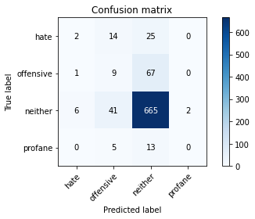

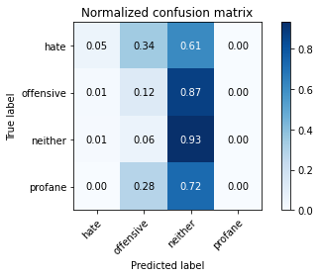

precision recall f1-score support

hate 0.22 0.05 0.08 41

offensive 0.13 0.12 0.12 77

neither 0.86 0.93 0.90 714

profane 0.00 0.00 0.00 18

accuracy 0.80 850

macro avg 0.30 0.27 0.27 850

weighted avg 0.75 0.80 0.77 850

average eval_loss: 0.7774385996487772, accuracy: 0.7952941176470588

training 5 epoch...

33.04371094703674 seconds used......

5 training finished! average train loss: 0.0644500332394449

evaluating...

Confusion matrix, without normalization

[[ 0 1 40 0]

[ 0 1 76 0]

[ 2 4 706 2]

[ 0 1 17 0]]

Normalized confusion matrix

[[0. 0.02439024 0.97560976 0. ]

[0. 0.01298701 0.98701299 0. ]

[0.00280112 0.00560224 0.98879552 0.00280112]

[0. 0.05555556 0.94444444 0. ]]

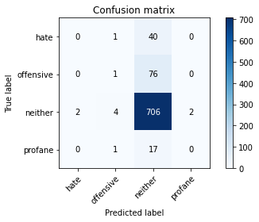

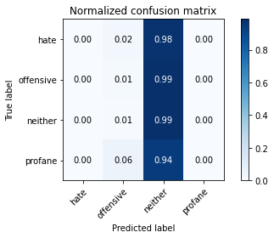

precision recall f1-score support

hate 0.00 0.00 0.00 41

offensive 0.14 0.01 0.02 77

neither 0.84 0.99 0.91 714

profane 0.00 0.00 0.00 18

accuracy 0.83 850

macro avg 0.25 0.25 0.23 850

weighted avg 0.72 0.83 0.77 850

average eval_loss: 1.168063752338301, accuracy: 0.831764705882353

training 6 epoch...

32.97361922264099 seconds used......

6 training finished! average train loss: 0.027008455232363584

evaluating...

Confusion matrix, without normalization

[[ 0 3 38 0]

[ 0 7 68 2]

[ 2 7 698 7]

[ 0 0 16 2]]

Normalized confusion matrix

[[0. 0.07317073 0.92682927 0. ]

[0. 0.09090909 0.88311688 0.02597403]

[0.00280112 0.00980392 0.97759104 0.00980392]

[0. 0. 0.88888889 0.11111111]]

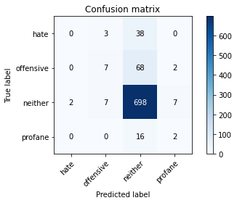

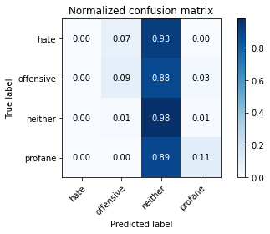

precision recall f1-score support

hate 0.00 0.00 0.00 41

offensive 0.41 0.09 0.15 77

neither 0.85 0.98 0.91 714

profane 0.18 0.11 0.14 18

accuracy 0.83 850

macro avg 0.36 0.29 0.30 850

weighted avg 0.76 0.83 0.78 850

average eval_loss: 1.0615550840102939, accuracy: 0.831764705882353

training 7 epoch...

32.94104528427124 seconds used......

7 training finished! average train loss: 0.011948132756286842

evaluating...

Confusion matrix, without normalization

[[ 2 11 28 0]

[ 2 20 55 0]

[ 12 40 656 6]

[ 1 7 10 0]]

Normalized confusion matrix

[[0.04878049 0.26829268 0.68292683 0. ]

[0.02597403 0.25974026 0.71428571 0. ]

[0.01680672 0.05602241 0.91876751 0.00840336]

[0.05555556 0.38888889 0.55555556 0. ]]

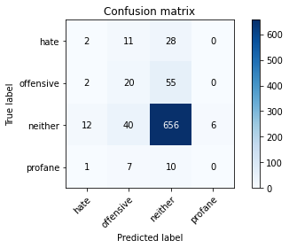

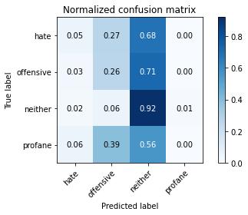

precision recall f1-score support

hate 0.12 0.05 0.07 41

offensive 0.26 0.26 0.26 77

neither 0.88 0.92 0.90 714

profane 0.00 0.00 0.00 18

accuracy 0.80 850

macro avg 0.31 0.31 0.31 850

weighted avg 0.76 0.80 0.78 850

average eval_loss: 0.9801163676378946, accuracy: 0.7976470588235294

training 8 epoch...

32.90182900428772 seconds used......

8 training finished! average train loss: 0.004203887299466293

evaluating...

Confusion matrix, without normalization

[[ 1 3 37 0]

[ 1 8 68 0]

[ 4 9 699 2]

[ 0 1 17 0]]

Normalized confusion matrix

[[0.02439024 0.07317073 0.90243902 0. ]

[0.01298701 0.1038961 0.88311688 0. ]

[0.00560224 0.01260504 0.9789916 0.00280112]

[0. 0.05555556 0.94444444 0. ]]

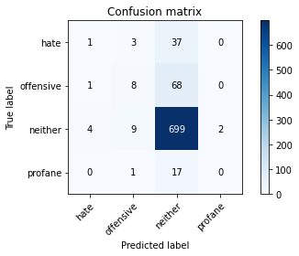

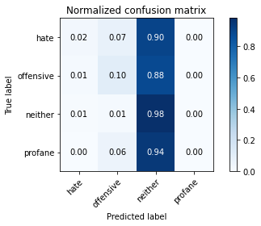

precision recall f1-score support

hate 0.17 0.02 0.04 41

offensive 0.38 0.10 0.16 77

neither 0.85 0.98 0.91 714

profane 0.00 0.00 0.00 18

accuracy 0.83 850

macro avg 0.35 0.28 0.28 850

weighted avg 0.76 0.83 0.78 850

average eval_loss: 1.202131368879088, accuracy: 0.8329411764705882

training 9 epoch...

33.04493546485901 seconds used......

9 training finished! average train loss: 0.0020773272137937786

evaluating...

Confusion matrix, without normalization

[[ 1 5 35 0]

[ 0 11 65 1]

[ 5 19 683 7]

[ 0 1 16 1]]

Normalized confusion matrix

[[0.02439024 0.12195122 0.85365854 0. ]

[0. 0.14285714 0.84415584 0.01298701]

[0.0070028 0.02661064 0.95658263 0.00980392]

[0. 0.05555556 0.88888889 0.05555556]]

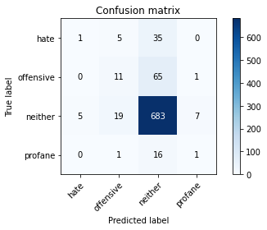

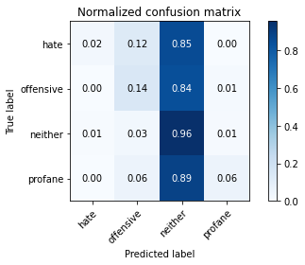

precision recall f1-score support

hate 0.17 0.02 0.04 41

offensive 0.31 0.14 0.19 77

neither 0.85 0.96 0.90 714

profane 0.11 0.06 0.07 18

accuracy 0.82 850

macro avg 0.36 0.29 0.30 850

weighted avg 0.76 0.82 0.78 850

average eval_loss: 1.1602716593049482, accuracy: 0.8188235294117647

training 10 epoch...

32.91484498977661 seconds used......

10 training finished! average train loss: 0.008468620038054353

evaluating...

Confusion matrix, without normalization

[[ 3 7 31 0]

[ 2 21 52 2]

[ 11 27 667 9]

[ 1 2 11 4]]

Normalized confusion matrix

[[0.07317073 0.17073171 0.75609756 0. ]

[0.02597403 0.27272727 0.67532468 0.02597403]

[0.01540616 0.03781513 0.93417367 0.01260504]

[0.05555556 0.11111111 0.61111111 0.22222222]]

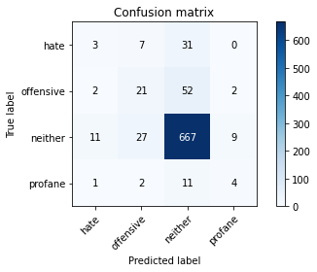

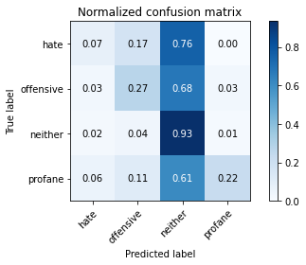

precision recall f1-score support

hate 0.18 0.07 0.10 41

offensive 0.37 0.27 0.31 77

neither 0.88 0.93 0.90 714

profane 0.27 0.22 0.24 18

accuracy 0.82 850

macro avg 0.42 0.38 0.39 850

weighted avg 0.78 0.82 0.80 850

average eval_loss: 0.9485518977771578, accuracy: 0.8176470588235294

4 run......

training 1 epoch...

32.916754484176636 seconds used......

1 training finished! average train loss: 0.4424099227832874

evaluating...

Confusion matrix, without normalization

[[ 0 0 41 0]

[ 0 0 77 0]

[ 0 0 714 0]

[ 0 0 18 0]]

Normalized confusion matrix

[[0. 0. 1. 0.]

[0. 0. 1. 0.]

[0. 0. 1. 0.]

[0. 0. 1. 0.]]





/opt/conda/lib/python3.7/site-packages/sklearn/metrics/_classification.py:1245: UndefinedMetricWarning: Precision and F-score are ill-defined and being set to 0.0 in labels with no predicted samples. Use `zero_division` parameter to control this behavior.

_warn_prf(average, modifier, msg_start, len(result))

/opt/conda/lib/python3.7/site-packages/sklearn/metrics/_classification.py:1245: UndefinedMetricWarning: Precision and F-score are ill-defined and being set to 0.0 in labels with no predicted samples. Use `zero_division` parameter to control this behavior.

_warn_prf(average, modifier, msg_start, len(result))

/opt/conda/lib/python3.7/site-packages/sklearn/metrics/_classification.py:1245: UndefinedMetricWarning: Precision and F-score are ill-defined and being set to 0.0 in labels with no predicted samples. Use `zero_division` parameter to control this behavior.

_warn_prf(average, modifier, msg_start, len(result))

precision recall f1-score support

hate 0.00 0.00 0.00 41

offensive 0.00 0.00 0.00 77

neither 0.84 1.00 0.91 714

profane 0.00 0.00 0.00 18

accuracy 0.84 850

macro avg 0.21 0.25 0.23 850

weighted avg 0.71 0.84 0.77 850

average eval_loss: 0.57887492510815, accuracy: 0.84

training 2 epoch...

32.956486225128174 seconds used......

2 training finished! average train loss: 0.35268806363821653

evaluating...

Confusion matrix, without normalization

[[ 0 0 41 0]

[ 0 0 77 0]

[ 0 0 714 0]

[ 0 0 18 0]]

Normalized confusion matrix

[[0. 0. 1. 0.]

[0. 0. 1. 0.]

[0. 0. 1. 0.]

[0. 0. 1. 0.]]





/opt/conda/lib/python3.7/site-packages/sklearn/metrics/_classification.py:1245: UndefinedMetricWarning: Precision and F-score are ill-defined and being set to 0.0 in labels with no predicted samples. Use `zero_division` parameter to control this behavior.

_warn_prf(average, modifier, msg_start, len(result))

/opt/conda/lib/python3.7/site-packages/sklearn/metrics/_classification.py:1245: UndefinedMetricWarning: Precision and F-score are ill-defined and being set to 0.0 in labels with no predicted samples. Use `zero_division` parameter to control this behavior.

_warn_prf(average, modifier, msg_start, len(result))

/opt/conda/lib/python3.7/site-packages/sklearn/metrics/_classification.py:1245: UndefinedMetricWarning: Precision and F-score are ill-defined and being set to 0.0 in labels with no predicted samples. Use `zero_division` parameter to control this behavior.

_warn_prf(average, modifier, msg_start, len(result))

precision recall f1-score support

hate 0.00 0.00 0.00 41

offensive 0.00 0.00 0.00 77

neither 0.84 1.00 0.91 714

profane 0.00 0.00 0.00 18

accuracy 0.84 850

macro avg 0.21 0.25 0.23 850

weighted avg 0.71 0.84 0.77 850

average eval_loss: 0.6480802412491379, accuracy: 0.84

training 3 epoch...

32.88873314857483 seconds used......

3 training finished! average train loss: 0.2274640596359578

evaluating...

Confusion matrix, without normalization

[[ 0 1 40 0]

[ 1 0 76 0]

[ 0 2 712 0]

[ 0 0 18 0]]

Normalized confusion matrix

[[0. 0.02439024 0.97560976 0. ]

[0.01298701 0. 0.98701299 0. ]

[0. 0.00280112 0.99719888 0. ]

[0. 0. 1. 0. ]]

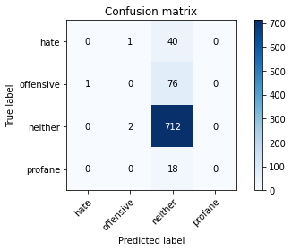

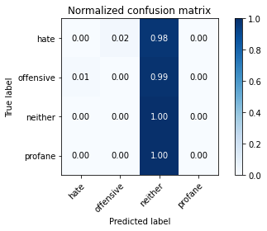

/opt/conda/lib/python3.7/site-packages/sklearn/metrics/_classification.py:1245: UndefinedMetricWarning: Precision and F-score are ill-defined and being set to 0.0 in labels with no predicted samples. Use `zero_division` parameter to control this behavior.

_warn_prf(average, modifier, msg_start, len(result))

/opt/conda/lib/python3.7/site-packages/sklearn/metrics/_classification.py:1245: UndefinedMetricWarning: Precision and F-score are ill-defined and being set to 0.0 in labels with no predicted samples. Use `zero_division` parameter to control this behavior.

_warn_prf(average, modifier, msg_start, len(result))

/opt/conda/lib/python3.7/site-packages/sklearn/metrics/_classification.py:1245: UndefinedMetricWarning: Precision and F-score are ill-defined and being set to 0.0 in labels with no predicted samples. Use `zero_division` parameter to control this behavior.

_warn_prf(average, modifier, msg_start, len(result))

precision recall f1-score support

hate 0.00 0.00 0.00 41

offensive 0.00 0.00 0.00 77

neither 0.84 1.00 0.91 714

profane 0.00 0.00 0.00 18

accuracy 0.84 850

macro avg 0.21 0.25 0.23 850

weighted avg 0.71 0.84 0.77 850

average eval_loss: 0.8500625698280326, accuracy: 0.8376470588235294

training 4 epoch...

32.80728101730347 seconds used......

4 training finished! average train loss: 0.10378961292271019

evaluating...

Confusion matrix, without normalization

[[ 0 7 34 0]

[ 2 2 73 0]

[ 6 25 682 1]

[ 0 5 13 0]]

Normalized confusion matrix

[[0. 0.17073171 0.82926829 0. ]

[0.02597403 0.02597403 0.94805195 0. ]

[0.00840336 0.03501401 0.95518207 0.00140056]

[0. 0.27777778 0.72222222 0. ]]

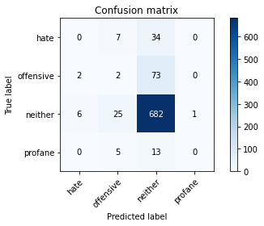

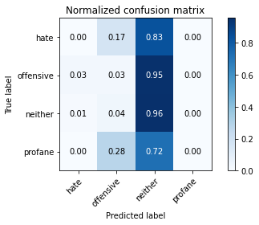

precision recall f1-score support

hate 0.00 0.00 0.00 41

offensive 0.05 0.03 0.03 77

neither 0.85 0.96 0.90 714

profane 0.00 0.00 0.00 18

accuracy 0.80 850

macro avg 0.23 0.25 0.23 850

weighted avg 0.72 0.80 0.76 850

average eval_loss: 0.9684750493724159, accuracy: 0.8047058823529412

training 5 epoch...

32.82204222679138 seconds used......

5 training finished! average train loss: 0.0450072260799023

evaluating...

Confusion matrix, without normalization

[[ 0 5 36 0]

[ 1 16 60 0]

[ 4 22 687 1]

[ 0 7 11 0]]

Normalized confusion matrix

[[0. 0.12195122 0.87804878 0. ]

[0.01298701 0.20779221 0.77922078 0. ]

[0.00560224 0.03081232 0.96218487 0.00140056]

[0. 0.38888889 0.61111111 0. ]]

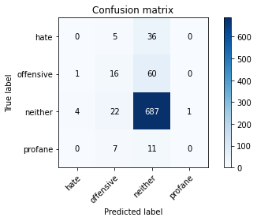

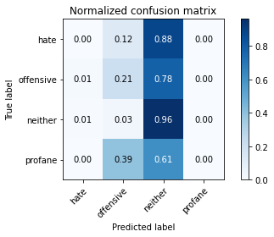

precision recall f1-score support

hate 0.00 0.00 0.00 41

offensive 0.32 0.21 0.25 77

neither 0.87 0.96 0.91 714

profane 0.00 0.00 0.00 18

accuracy 0.83 850

macro avg 0.30 0.29 0.29 850

weighted avg 0.76 0.83 0.79 850

average eval_loss: 0.8351764843175133, accuracy: 0.8270588235294117

training 6 epoch...

32.897953510284424 seconds used......

6 training finished! average train loss: 0.021205685268453667

evaluating...

Confusion matrix, without normalization

[[ 1 3 37 0]

[ 2 11 62 2]

[ 7 19 681 7]

[ 1 4 12 1]]

Normalized confusion matrix

[[0.02439024 0.07317073 0.90243902 0. ]

[0.02597403 0.14285714 0.80519481 0.02597403]

[0.00980392 0.02661064 0.95378151 0.00980392]

[0.05555556 0.22222222 0.66666667 0.05555556]]

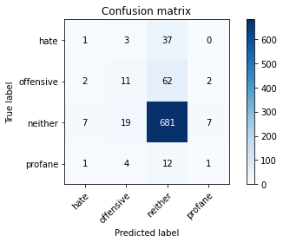

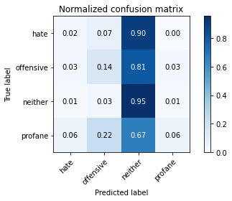

precision recall f1-score support

hate 0.09 0.02 0.04 41

offensive 0.30 0.14 0.19 77

neither 0.86 0.95 0.90 714

profane 0.10 0.06 0.07 18

accuracy 0.82 850

macro avg 0.34 0.29 0.30 850

weighted avg 0.76 0.82 0.78 850

average eval_loss: 0.9646644603371685, accuracy: 0.8164705882352942

training 7 epoch...

32.82884883880615 seconds used......

7 training finished! average train loss: 0.008163768467304409

evaluating...

Confusion matrix, without normalization

[[ 2 1 38 0]

[ 5 4 68 0]

[ 19 9 684 2]

[ 2 0 16 0]]

Normalized confusion matrix

[[0.04878049 0.02439024 0.92682927 0. ]

[0.06493506 0.05194805 0.88311688 0. ]

[0.02661064 0.01260504 0.95798319 0.00280112]

[0.11111111 0. 0.88888889 0. ]]

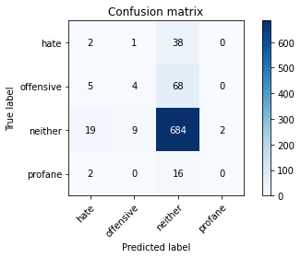

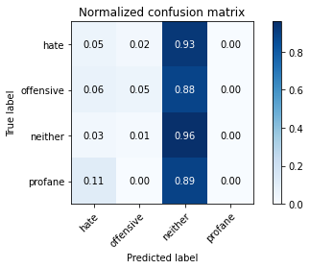

precision recall f1-score support

hate 0.07 0.05 0.06 41

offensive 0.29 0.05 0.09 77

neither 0.85 0.96 0.90 714

profane 0.00 0.00 0.00 18

accuracy 0.81 850

macro avg 0.30 0.26 0.26 850

weighted avg 0.74 0.81 0.77 850

average eval_loss: 1.174324428395478, accuracy: 0.8117647058823529

training 8 epoch...

32.89371991157532 seconds used......

8 training finished! average train loss: 0.005256176432954265

evaluating...

Confusion matrix, without normalization

[[ 0 1 40 0]

[ 1 2 74 0]

[ 8 11 694 1]

[ 0 1 17 0]]

Normalized confusion matrix

[[0. 0.02439024 0.97560976 0. ]

[0.01298701 0.02597403 0.96103896 0. ]

[0.01120448 0.01540616 0.9719888 0.00140056]

[0. 0.05555556 0.94444444 0. ]]

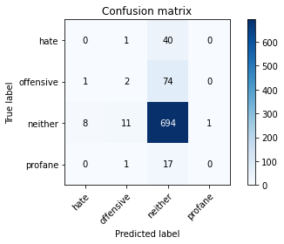

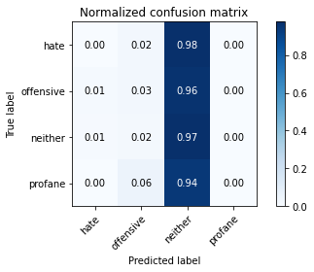

precision recall f1-score support

hate 0.00 0.00 0.00 41

offensive 0.13 0.03 0.04 77

neither 0.84 0.97 0.90 714

profane 0.00 0.00 0.00 18

accuracy 0.82 850

macro avg 0.24 0.25 0.24 850

weighted avg 0.72 0.82 0.76 850

average eval_loss: 1.2644143413801727, accuracy: 0.8188235294117647

training 9 epoch...

32.79813551902771 seconds used......

9 training finished! average train loss: 0.0019200881127132766

evaluating...

Confusion matrix, without normalization

[[ 1 8 32 0]

[ 5 15 56 1]

[ 14 33 664 3]

[ 1 7 10 0]]

Normalized confusion matrix

[[0.02439024 0.19512195 0.7804878 0. ]

[0.06493506 0.19480519 0.72727273 0.01298701]

[0.01960784 0.04621849 0.92997199 0.00420168]

[0.05555556 0.38888889 0.55555556 0. ]]

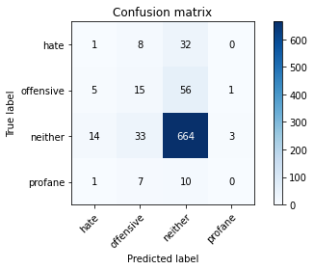

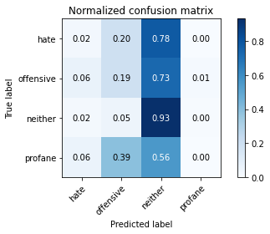

precision recall f1-score support

hate 0.05 0.02 0.03 41

offensive 0.24 0.19 0.21 77

neither 0.87 0.93 0.90 714

profane 0.00 0.00 0.00 18

accuracy 0.80 850

macro avg 0.29 0.29 0.29 850

weighted avg 0.76 0.80 0.78 850

average eval_loss: 1.1292018091165985, accuracy: 0.8

training 10 epoch...

32.83534002304077 seconds used......

10 training finished! average train loss: 0.009107067023360668

evaluating...

Confusion matrix, without normalization

[[ 0 10 31 0]

[ 1 23 53 0]

[ 1 35 673 5]

[ 0 6 12 0]]

Normalized confusion matrix

[[0. 0.24390244 0.75609756 0. ]

[0.01298701 0.2987013 0.68831169 0. ]

[0.00140056 0.04901961 0.94257703 0.0070028 ]

[0. 0.33333333 0.66666667 0. ]]

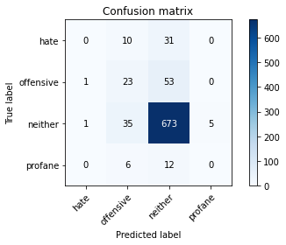

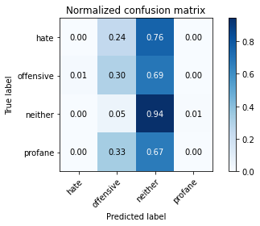

precision recall f1-score support

hate 0.00 0.00 0.00 41

offensive 0.31 0.30 0.30 77

neither 0.88 0.94 0.91 714

profane 0.00 0.00 0.00 18

accuracy 0.82 850

macro avg 0.30 0.31 0.30 850

weighted avg 0.76 0.82 0.79 850

average eval_loss: 1.0563562373498043, accuracy: 0.8188235294117647

5 run......

training 1 epoch...

32.814882040023804 seconds used......

1 training finished! average train loss: 0.48837558862738584

evaluating...

Confusion matrix, without normalization

[[ 0 0 41 0]

[ 0 0 77 0]

[ 0 0 714 0]

[ 0 0 18 0]]

Normalized confusion matrix

[[0. 0. 1. 0.]

[0. 0. 1. 0.]

[0. 0. 1. 0.]

[0. 0. 1. 0.]]





/opt/conda/lib/python3.7/site-packages/sklearn/metrics/_classification.py:1245: UndefinedMetricWarning: Precision and F-score are ill-defined and being set to 0.0 in labels with no predicted samples. Use `zero_division` parameter to control this behavior.

_warn_prf(average, modifier, msg_start, len(result))

/opt/conda/lib/python3.7/site-packages/sklearn/metrics/_classification.py:1245: UndefinedMetricWarning: Precision and F-score are ill-defined and being set to 0.0 in labels with no predicted samples. Use `zero_division` parameter to control this behavior.

_warn_prf(average, modifier, msg_start, len(result))

/opt/conda/lib/python3.7/site-packages/sklearn/metrics/_classification.py:1245: UndefinedMetricWarning: Precision and F-score are ill-defined and being set to 0.0 in labels with no predicted samples. Use `zero_division` parameter to control this behavior.

_warn_prf(average, modifier, msg_start, len(result))

precision recall f1-score support

hate 0.00 0.00 0.00 41

offensive 0.00 0.00 0.00 77

neither 0.84 1.00 0.91 714

profane 0.00 0.00 0.00 18

accuracy 0.84 850

macro avg 0.21 0.25 0.23 850

weighted avg 0.71 0.84 0.77 850

average eval_loss: 0.6137009917563477, accuracy: 0.84

training 2 epoch...

32.82985186576843 seconds used......

2 training finished! average train loss: 0.3896990079842313

evaluating...

Confusion matrix, without normalization

[[ 0 0 41 0]

[ 0 0 77 0]

[ 0 0 714 0]

[ 0 0 18 0]]

Normalized confusion matrix

[[0. 0. 1. 0.]

[0. 0. 1. 0.]

[0. 0. 1. 0.]

[0. 0. 1. 0.]]





/opt/conda/lib/python3.7/site-packages/sklearn/metrics/_classification.py:1245: UndefinedMetricWarning: Precision and F-score are ill-defined and being set to 0.0 in labels with no predicted samples. Use `zero_division` parameter to control this behavior.

_warn_prf(average, modifier, msg_start, len(result))

/opt/conda/lib/python3.7/site-packages/sklearn/metrics/_classification.py:1245: UndefinedMetricWarning: Precision and F-score are ill-defined and being set to 0.0 in labels with no predicted samples. Use `zero_division` parameter to control this behavior.

_warn_prf(average, modifier, msg_start, len(result))

/opt/conda/lib/python3.7/site-packages/sklearn/metrics/_classification.py:1245: UndefinedMetricWarning: Precision and F-score are ill-defined and being set to 0.0 in labels with no predicted samples. Use `zero_division` parameter to control this behavior.

_warn_prf(average, modifier, msg_start, len(result))

precision recall f1-score support

hate 0.00 0.00 0.00 41

offensive 0.00 0.00 0.00 77

neither 0.84 1.00 0.91 714

profane 0.00 0.00 0.00 18

accuracy 0.84 850

macro avg 0.21 0.25 0.23 850

weighted avg 0.71 0.84 0.77 850

average eval_loss: 0.5529265054176713, accuracy: 0.84

training 3 epoch...

32.83513808250427 seconds used......

3 training finished! average train loss: 0.2770781141964241

evaluating...

Confusion matrix, without normalization

[[ 0 0 41 0]

[ 0 0 77 0]

[ 1 2 711 0]

[ 0 0 17 1]]

Normalized confusion matrix

[[0. 0. 1. 0. ]

[0. 0. 1. 0. ]

[0.00140056 0.00280112 0.99579832 0. ]

[0. 0. 0.94444444 0.05555556]]

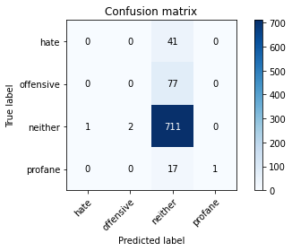

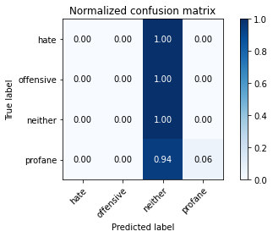

precision recall f1-score support

hate 0.00 0.00 0.00 41

offensive 0.00 0.00 0.00 77

neither 0.84 1.00 0.91 714

profane 1.00 0.06 0.11 18

accuracy 0.84 850

macro avg 0.46 0.26 0.25 850

weighted avg 0.73 0.84 0.77 850

average eval_loss: 0.6915562621014583, accuracy: 0.8376470588235294

training 4 epoch...

32.85688328742981 seconds used......

4 training finished! average train loss: 0.147507391470187

evaluating...

Confusion matrix, without normalization

[[ 0 0 41 0]

[ 0 1 76 0]

[ 1 0 713 0]

[ 0 1 17 0]]

Normalized confusion matrix

[[0. 0. 1. 0. ]

[0. 0.01298701 0.98701299 0. ]

[0.00140056 0. 0.99859944 0. ]

[0. 0.05555556 0.94444444 0. ]]

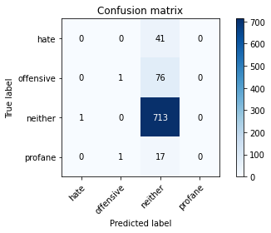

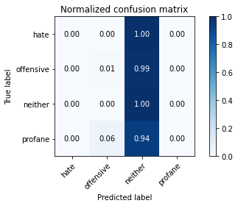

/opt/conda/lib/python3.7/site-packages/sklearn/metrics/_classification.py:1245: UndefinedMetricWarning: Precision and F-score are ill-defined and being set to 0.0 in labels with no predicted samples. Use `zero_division` parameter to control this behavior.

_warn_prf(average, modifier, msg_start, len(result))

/opt/conda/lib/python3.7/site-packages/sklearn/metrics/_classification.py:1245: UndefinedMetricWarning: Precision and F-score are ill-defined and being set to 0.0 in labels with no predicted samples. Use `zero_division` parameter to control this behavior.

_warn_prf(average, modifier, msg_start, len(result))

/opt/conda/lib/python3.7/site-packages/sklearn/metrics/_classification.py:1245: UndefinedMetricWarning: Precision and F-score are ill-defined and being set to 0.0 in labels with no predicted samples. Use `zero_division` parameter to control this behavior.

_warn_prf(average, modifier, msg_start, len(result))

precision recall f1-score support

hate 0.00 0.00 0.00 41

offensive 0.50 0.01 0.03 77

neither 0.84 1.00 0.91 714

profane 0.00 0.00 0.00 18

accuracy 0.84 850

macro avg 0.34 0.25 0.23 850

weighted avg 0.75 0.84 0.77 850

average eval_loss: 0.9728317418038238, accuracy: 0.84

training 5 epoch...

32.84883141517639 seconds used......

5 training finished! average train loss: 0.06432545006870054

evaluating...

Confusion matrix, without normalization

[[ 7 3 31 0]

[ 4 1 71 1]

[ 13 6 693 2]

[ 1 0 16 1]]

Normalized confusion matrix

[[0.17073171 0.07317073 0.75609756 0. ]

[0.05194805 0.01298701 0.92207792 0.01298701]

[0.01820728 0.00840336 0.97058824 0.00280112]

[0.05555556 0. 0.88888889 0.05555556]]

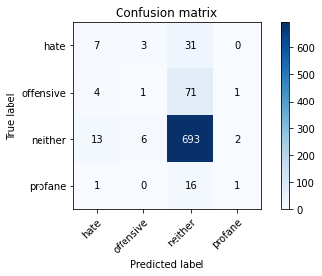

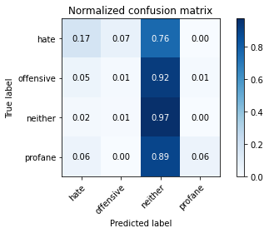

precision recall f1-score support

hate 0.28 0.17 0.21 41

offensive 0.10 0.01 0.02 77

neither 0.85 0.97 0.91 714

profane 0.25 0.06 0.09 18

accuracy 0.83 850

macro avg 0.37 0.30 0.31 850

weighted avg 0.75 0.83 0.78 850

average eval_loss: 0.9086990560415785, accuracy: 0.8258823529411765

training 6 epoch...

32.870983600616455 seconds used......

6 training finished! average train loss: 0.024963697737950773

evaluating...

Confusion matrix, without normalization

[[ 1 3 37 0]

[ 2 2 73 0]

[ 4 9 699 2]

[ 0 2 16 0]]

Normalized confusion matrix

[[0.02439024 0.07317073 0.90243902 0. ]

[0.02597403 0.02597403 0.94805195 0. ]

[0.00560224 0.01260504 0.9789916 0.00280112]

[0. 0.11111111 0.88888889 0. ]]

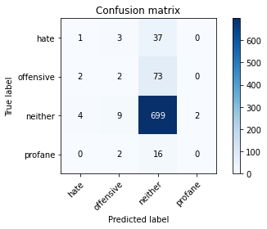

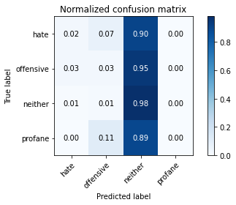

precision recall f1-score support

hate 0.14 0.02 0.04 41

offensive 0.12 0.03 0.04 77

neither 0.85 0.98 0.91 714

profane 0.00 0.00 0.00 18

accuracy 0.83 850

macro avg 0.28 0.26 0.25 850

weighted avg 0.73 0.83 0.77 850

average eval_loss: 1.1454741821629753, accuracy: 0.8258823529411765

training 7 epoch...

32.84099817276001 seconds used......

7 training finished! average train loss: 0.01370100564377002

evaluating...

Confusion matrix, without normalization

[[ 1 3 37 0]

[ 3 1 73 0]

[ 5 12 695 2]

[ 0 3 15 0]]

Normalized confusion matrix

[[0.02439024 0.07317073 0.90243902 0. ]

[0.03896104 0.01298701 0.94805195 0. ]

[0.0070028 0.01680672 0.97338936 0.00280112]

[0. 0.16666667 0.83333333 0. ]]

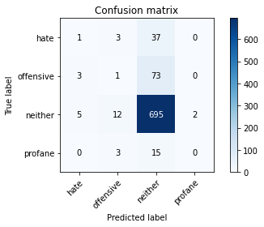

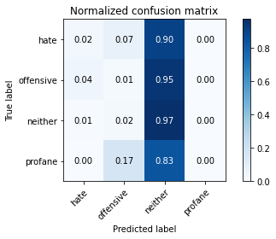

precision recall f1-score support

hate 0.11 0.02 0.04 41

offensive 0.05 0.01 0.02 77

neither 0.85 0.97 0.91 714

profane 0.00 0.00 0.00 18

accuracy 0.82 850

macro avg 0.25 0.25 0.24 850

weighted avg 0.72 0.82 0.76 850

average eval_loss: 1.1951073164053987, accuracy: 0.82

training 8 epoch...

32.76635932922363 seconds used......

8 training finished! average train loss: 0.004666277730388869

evaluating...

Confusion matrix, without normalization

[[ 1 2 38 0]

[ 2 1 74 0]

[ 3 8 703 0]

[ 0 2 16 0]]

Normalized confusion matrix

[[0.02439024 0.04878049 0.92682927 0. ]

[0.02597403 0.01298701 0.96103896 0. ]

[0.00420168 0.01120448 0.98459384 0. ]

[0. 0.11111111 0.88888889 0. ]]

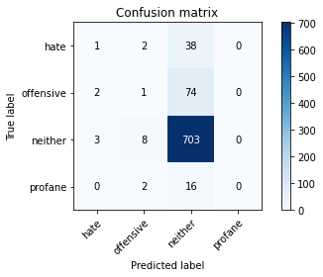

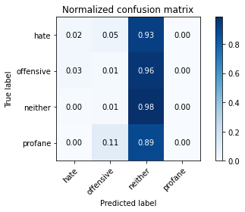

/opt/conda/lib/python3.7/site-packages/sklearn/metrics/_classification.py:1245: UndefinedMetricWarning: Precision and F-score are ill-defined and being set to 0.0 in labels with no predicted samples. Use `zero_division` parameter to control this behavior.

_warn_prf(average, modifier, msg_start, len(result))

/opt/conda/lib/python3.7/site-packages/sklearn/metrics/_classification.py:1245: UndefinedMetricWarning: Precision and F-score are ill-defined and being set to 0.0 in labels with no predicted samples. Use `zero_division` parameter to control this behavior.

_warn_prf(average, modifier, msg_start, len(result))

/opt/conda/lib/python3.7/site-packages/sklearn/metrics/_classification.py:1245: UndefinedMetricWarning: Precision and F-score are ill-defined and being set to 0.0 in labels with no predicted samples. Use `zero_division` parameter to control this behavior.

_warn_prf(average, modifier, msg_start, len(result))

precision recall f1-score support

hate 0.17 0.02 0.04 41

offensive 0.08 0.01 0.02 77

neither 0.85 0.98 0.91 714

profane 0.00 0.00 0.00 18

accuracy 0.83 850

macro avg 0.27 0.26 0.24 850

weighted avg 0.73 0.83 0.77 850

average eval_loss: 1.310774194937251, accuracy: 0.8294117647058824

training 9 epoch...

32.79239249229431 seconds used......

9 training finished! average train loss: 0.002167957648391109

evaluating...

Confusion matrix, without normalization

[[ 1 4 36 0]

[ 2 4 71 0]

[ 4 16 693 1]

[ 0 3 15 0]]

Normalized confusion matrix

[[0.02439024 0.09756098 0.87804878 0. ]

[0.02597403 0.05194805 0.92207792 0. ]

[0.00560224 0.02240896 0.97058824 0.00140056]

[0. 0.16666667 0.83333333 0. ]]

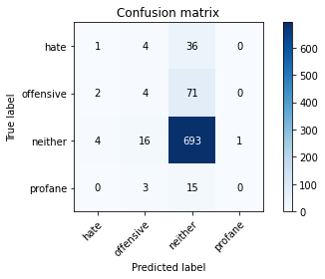

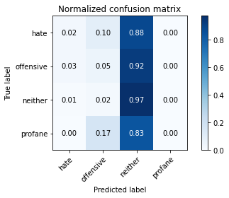

precision recall f1-score support

hate 0.14 0.02 0.04 41

offensive 0.15 0.05 0.08 77

neither 0.85 0.97 0.91 714

profane 0.00 0.00 0.00 18

accuracy 0.82 850

macro avg 0.29 0.26 0.26 850

weighted avg 0.73 0.82 0.77 850

average eval_loss: 1.322188653361166, accuracy: 0.8211764705882353

training 10 epoch...

32.801698207855225 seconds used......

10 training finished! average train loss: 0.0026928780413615514

evaluating...

Confusion matrix, without normalization

[[ 2 4 35 0]

[ 3 5 68 1]

[ 8 16 682 8]

[ 0 3 14 1]]

Normalized confusion matrix

[[0.04878049 0.09756098 0.85365854 0. ]

[0.03896104 0.06493506 0.88311688 0.01298701]

[0.01120448 0.02240896 0.95518207 0.01120448]

[0. 0.16666667 0.77777778 0.05555556]]

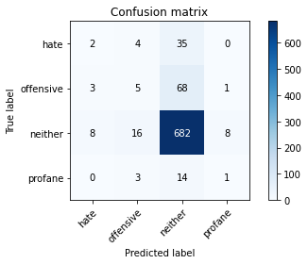

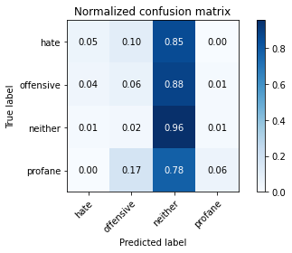

precision recall f1-score support

hate 0.15 0.05 0.07 41

offensive 0.18 0.06 0.10 77

neither 0.85 0.96 0.90 714

profane 0.10 0.06 0.07 18

accuracy 0.81 850

macro avg 0.32 0.28 0.29 850

weighted avg 0.74 0.81 0.77 850

average eval_loss: 1.22714671175954, accuracy: 0.8117647058823529